ms outlook setup for email account

Step 1. Open ms outlook

Step 2. Select 'Account Settings' from 'Tool' button

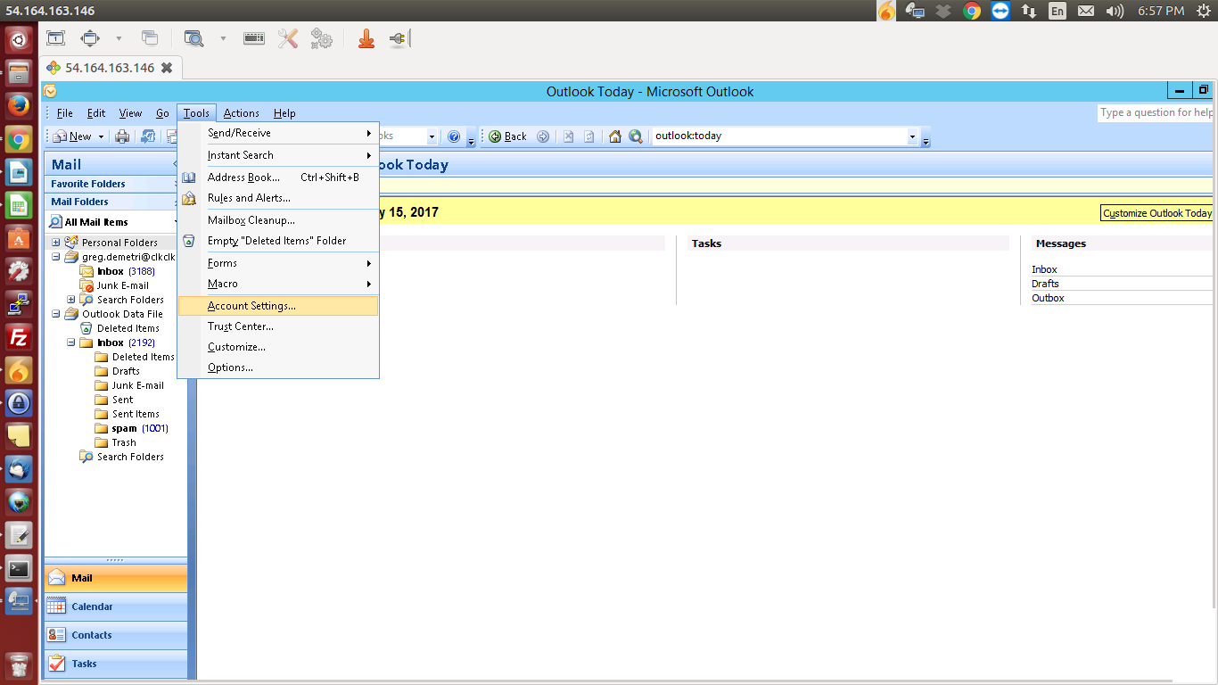
Step 3. Select 'New' from email tab

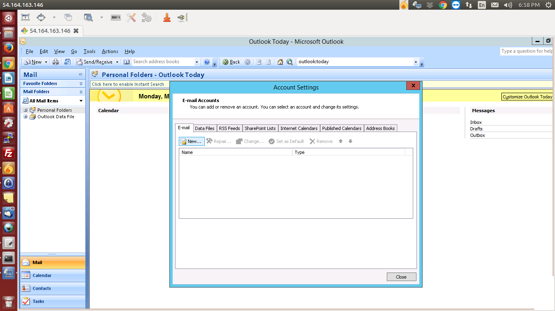

Step 4. Select 'Manually Configure server settings' & click 'Next'

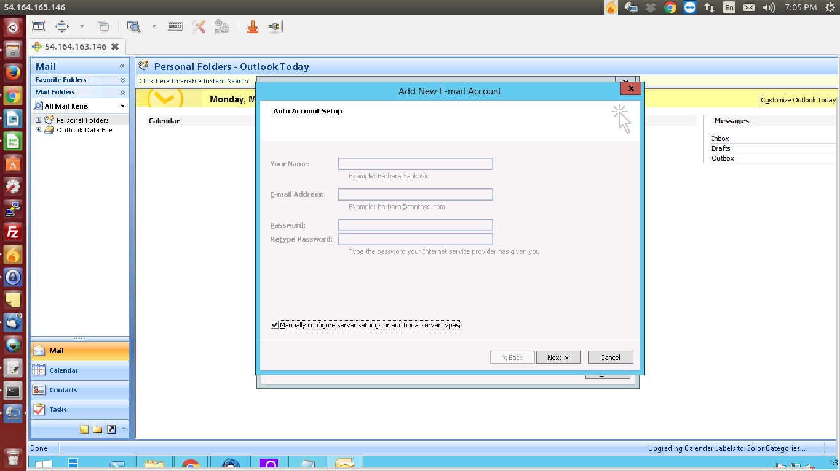

Step 5. Select Internet E-mail' & click Next

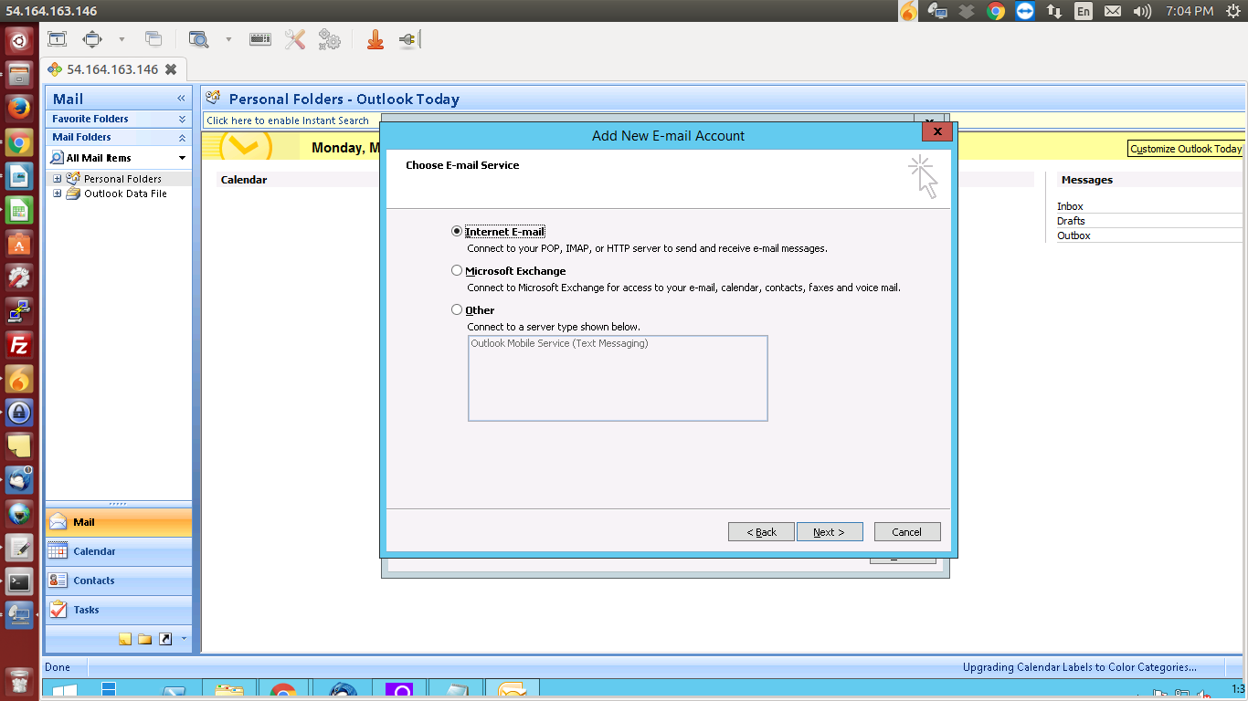

Step 6. Give your mail id as on 'Your Name' & 'Email Address'

Step 7. Select 'imap' as 'Account Type'

Step 8. Give 'zimbra.clkclk.com' as both 'Incoming mail server' & 'Outgoingmail server (smtp)'

Step 9. Set your mail id as your 'User name' & give the password

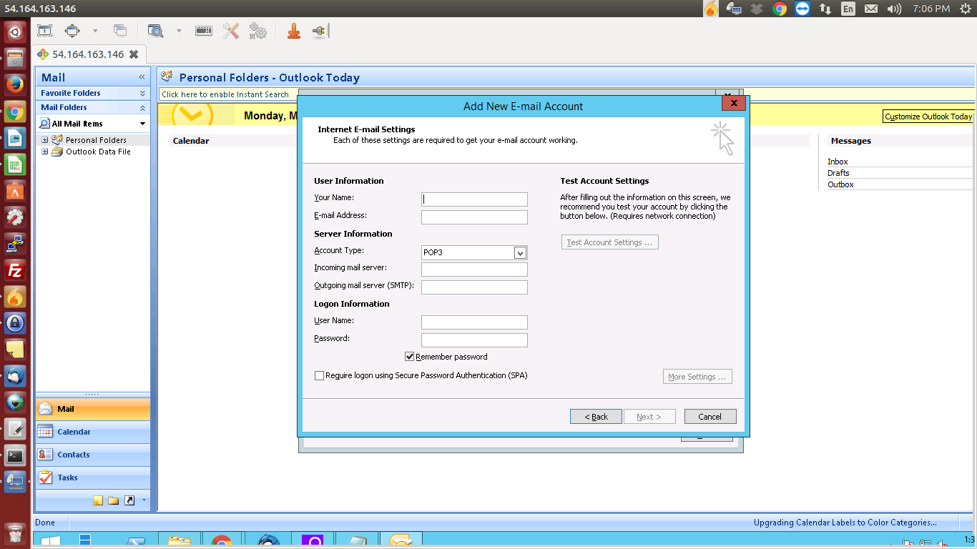

Step 10. Click on 'More settings'

Step 11. Click on Outgoing Server tab & check on 'My outgoing server requires authentication'

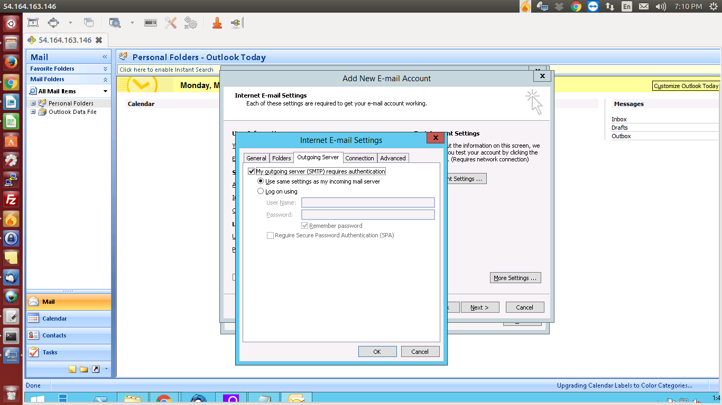

Step 12. Now click on Advanced tab . For Incoming server (IMAP) select protocol SSL & for Outgoing server (SMTP) select Auto & give port no. 587 & click OK

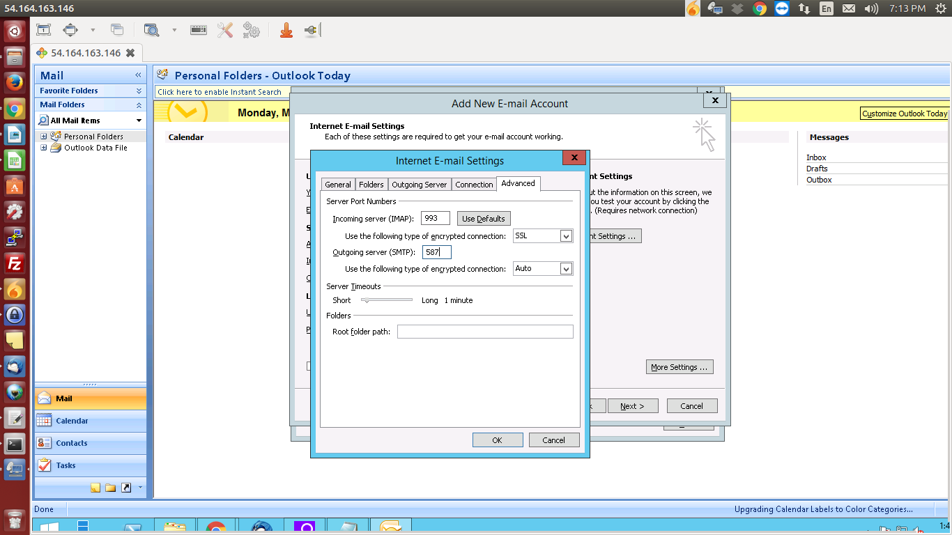

Step 13. Then click Next & then Finish .

